Coursework 1 – Data Visualization with Tableau

Finding 1

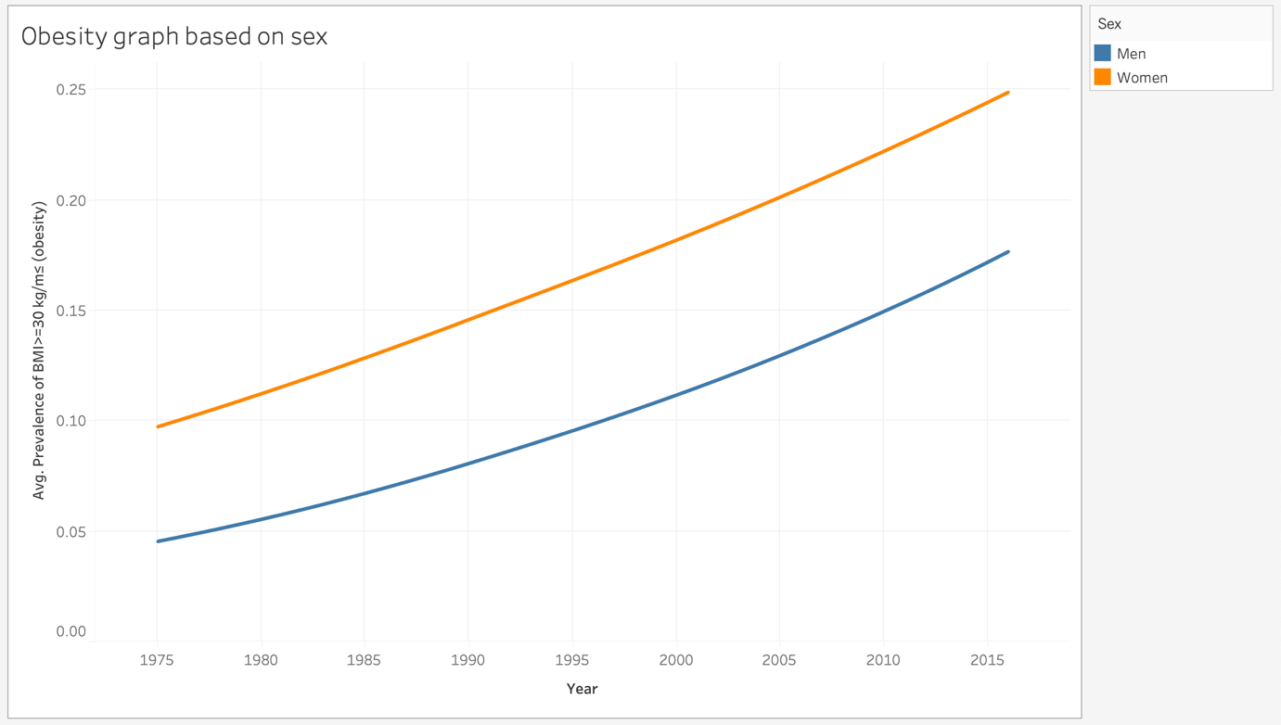

This finding is about knowing which gender has become more obese over the years from 1975 to 2015. The above graph depicts that both the gender has shown a significant hike in being obese among which women are comparatively on higher side. The interesting thing to observe here is that from the year 2006, men graph has shown a little bit of steepness whereas the women graph is almost a straight line. This might lead to our further observation in the next finding about diabetes from the year 2006 as obesity and diabetes has a correlation.

What?

* The **Dataset type** used here is a **Table** where **attributes(columns) is the** **Year** and **items(rows) is the** **Avg. Prevalence of BMI >=30kg/m^2.** The **cell containing value** will be the **value at a particular attribute and particular item**.
* The **Data Type**s used here are **Items** (Avg. Prevalence of BMI >=30kg/m^2) and **Attributes** (Year).
* The Attribute type used here is **Ordered** under which we are using **Quantitative** type.

Why?

* The above visualization aims to depict the picture of obesity level based on gender (Male and Female).
* After **consuming** the given data and to **present** the significant increase in the obesity level, I **looked up** for the range of years and started **locating** the mean of “average prevalence of BMI” values. I **compared** the graphs of men and women individually and then **summarized** them into one graph to understand the visualization better.
* The finding above shows the **trends** of how obesity level has significantly raised over the years in both the genders (Men and Women). There is **correlation** of different obesity valuesin different subsequent year ranges.

How?

* The mark used in above graph is a **one-dimensional (1D) mark: line.**
* The channels used are below: -
  + **Position**: Vertical position and Horizontal position.
  + **Colour**
  + **Tilt** (to show the rising obesity graph over the years).
* The **gender** here is a **categorical attribute** that is **mapped to a Colour hue** attribute to distinguish between the Male and Female.
* The **line mark is mapped to Title/angle ordered attribute** to show the significant rise in obese level over the years.
* The line chart is better here because our aim to visualize the increase level of obesity over the years between men and women. In line chart, the distinction between men and women are simple enough to understand. Moreover, to understand how obesity level is differing over different years, line chart is the simplistic option to go for as it connects the dots between x-axis and y-axis and give a clear picture on the variation or frequency.
* To understand the obesity level in both the genders in one graph, we need to distinguish their representations. Colour hue is the best option as it clearly represents which gender has which line chart.

Finding 1.1

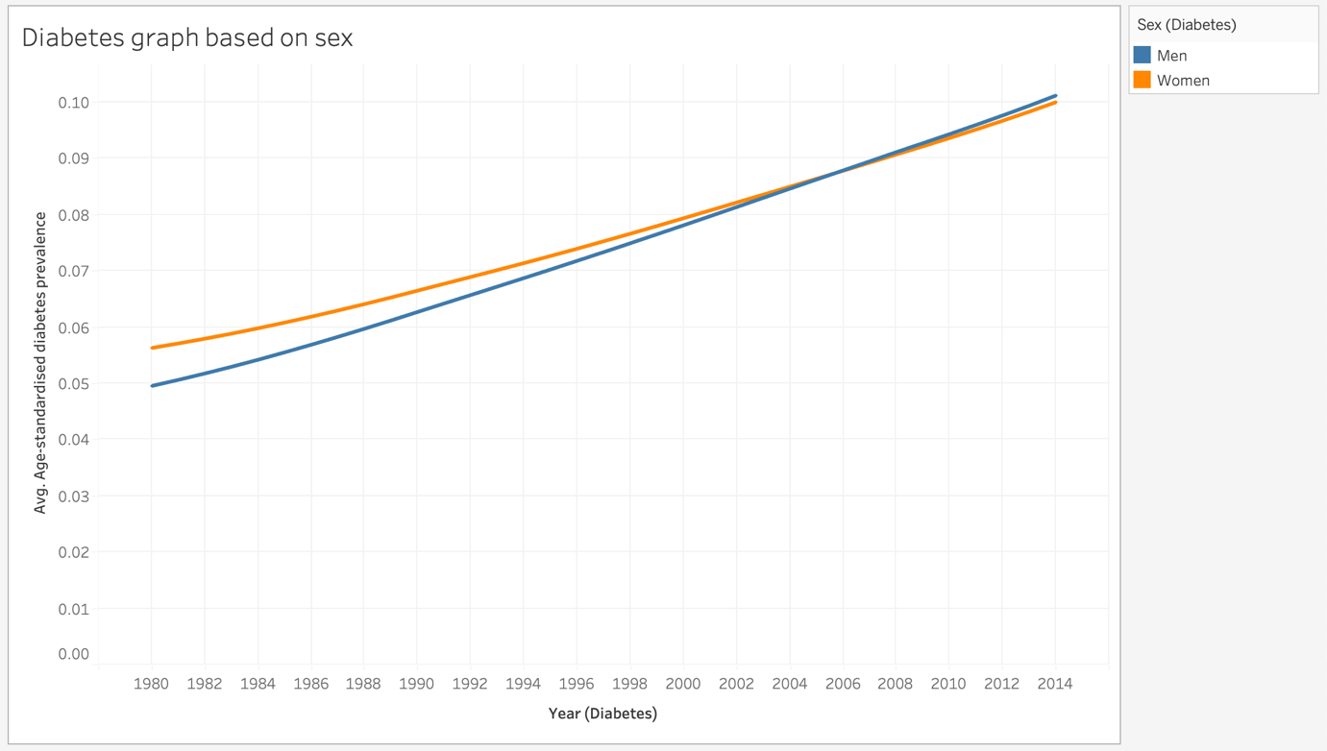

This finding is about knowing which gender is more diabetic over the years from 1975 to 2015. The above graph depicts that both the gender has shown a significant hike in being diabetic but from the year 2006, men tend to be more diabetic than women. This proves our theory in the previous finding that obesity has a correlation with diabetes.

What?

* The **Dataset type** used here is a **Table** where **attributes(columns) is the** **Year** and **items(rows) is the** **Age-standardised diabetes prevalence.** The **cell containing value** will be the **value at a particular attribute and particular item**.
* The **Data Type**s used here are **Items** (Age-standardised diabetes prevalence) and **Attributes** (Year).
* The Attribute type used here is **Ordered** under which we are using **Quantitative** type.

Why?

* The above visualization aims to depict the picture of diabetes level based on gender (Male and Female).
* After **consuming** the given data and to **present** the significant increase in the obesity level, I **looked up** for the range of years and started **locating** the mean of “Age-standardised diabetes prevalence” values. I **compared** the graphs of men and women individually and then **summarized** them into one graph to understand the visualization better.
* The finding above shows the **trends** of how diabetes level has significantly raised over the years in both the genders (Men and Women). There is **correlation** of different diabetes valuesin different subsequent year ranges.

How?

* The mark used in above graph is a one-dimensional (1D) mark: line.
* The channels used are below: -
  + Position: Vertical position and Horizontal position.
  + Colour
  + Tilt (to show the rising diabetes graph over the years).
* The gender here is a categorical attribute that is mapped to a Colour hue attribute to distinguish between the Male and Female.
* The line mark is mapped to Title/angle ordered attribute to show the significant rise in diabetes level over the years.
* The line chart is better here because our aim to visualize the increase level of diabetes over the years between men and women. In line chart, the distinction between men and women are simple enough to understand. Moreover, to understand how diabetes level is differing over different years, line chart is the simplistic option to go for as it connects the dots between x-axis and y-axis and give a clear picture on the variation or frequency.
* To understand the diabetes level in both the genders in one graph, we need to distinguish their representations. Colour hue is the best option as it clearly represents which gender has which line chart.

Finding 1.2

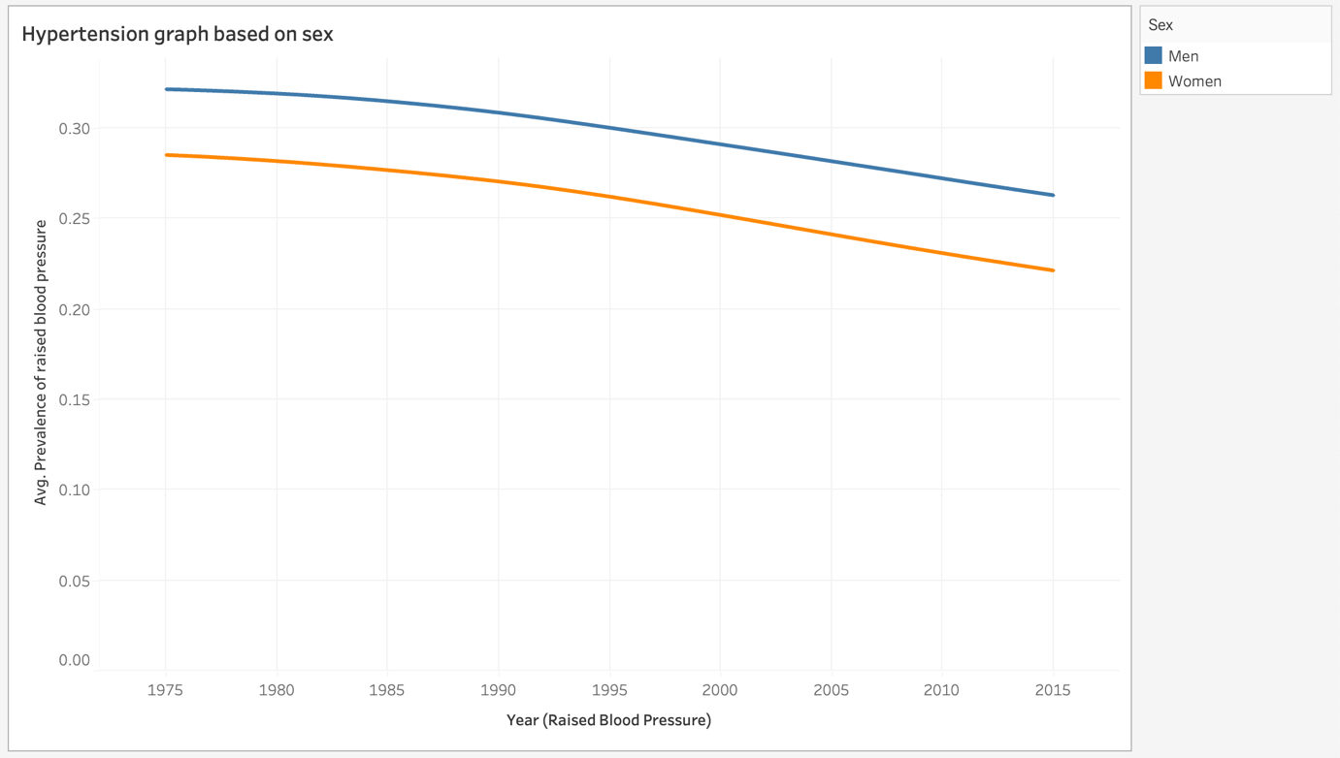

This finding is about knowing whether increase in obesity has any impact on the hypertension or high blood pressure among males and females over the years from 1975 to 2015. The above graph depicts that both the gender has shown a gradual drop in having a high blood pressure. This proves that the obesity has a negative correlation with high blood pressure as per the given data.

What?

* The **Dataset type** used here is a **Table** where **attributes(columns) is the** **Year** and **items(rows) is the** **Prevalence of raised blood pressure.** The **cell containing value** will be the **value at a particular attribute and particular item**.
* The **Data Types** used here are **Items** (**Age-standardised diabetes prevalence**) and **Attributes** (Year).
* The **Attribute type** used here is **Ordered** under which we are using **Quantitative** type.

Why?

* The above visualization aims to derive a correlation between obesity and high blood pressure.
* After **consuming** the given data and to **present** the significant increase in the obesity level, I **looked up** for the range of years and started **locating** the mean of “Prevalence of raised blood pressure” values. I **compared** the graphs of men and women individually and then **summarized** them into one graph to understand the visualization better.
* The finding above shows the **trends** of how high blood pressure or hypertension has decreased over the years in both the genders (Men and Women). There is **correlation** of different high blood pressure valuesin different subsequent year ranges.

How?

* The mark used in above graph is a **one-dimensional (1D) mark: line.**
* The channels used are below: -
  + **Position: Vertical position and Horizontal position.**
  + **Colour**
  + **Tilt** (to show the drop in “avg. high blood pressure” graph over the years).
* The **gender** here is a **categorical attribute** that is mapped to **a Colour hue** attribute to distinguish between the Male and Female.
* The **line mark is mapped to Title/angle ordered attribute** to show the fall in high blood pressure level over the years.
* The line chart is better here because our aim is to understand the correlation between being obese and having a hypertension or high blood pressure. In line chart, the distinction between men and women are simple enough to understand. Moreover, to understand how high blood pressure level is differing over different years, line chart is the simplistic option to go for as it connects the dots between x-axis and y-axis and give a clear picture on the variation or frequency.
* To understand the high blood pressure level in both the genders in one graph, we need to distinguish their representations. Colour hue is the best option as it clearly represents which gender has which line chart.

Finding 2

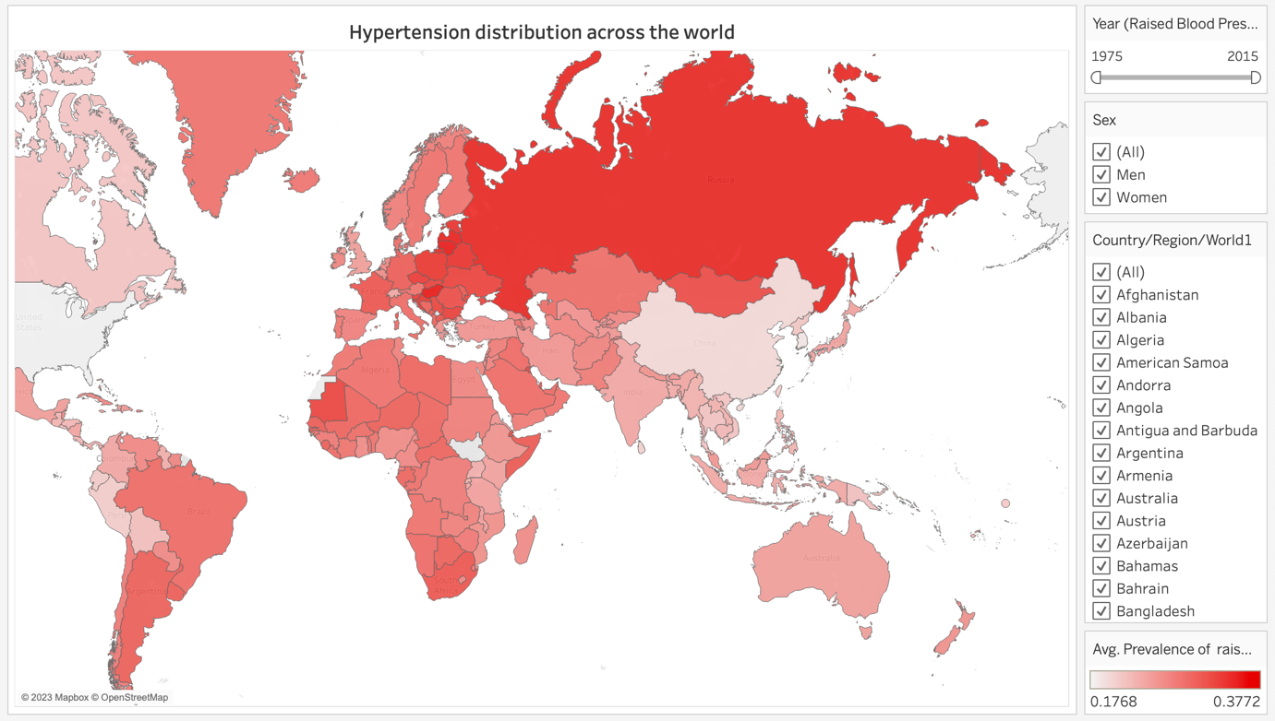

This finding is about understanding the distribution of high blood pressure or hypertension at global level. The reason I chose this finding because in recent past years, there has been huge spike in the cardiovascular diseases such as arteries blockages that leads to sudden heart attack. The prime reason for this has always been a rise in blood pressure.

There were two countries in the data set, **Macedonia (TFYR) and Occupied Palestinian Territory** **for which Latitude and Longitude were not auto generated**. These were being shows as 2 unknown parameters and their data was not represented in the above map view. *To correct this, I have mapped* ***Macedonia (TFYR) with North Macedonia*** *and* ***Occupied Palestinian Territory with Palestine.***

What?

* The **Dataset type** used here is a **Table** where **attributes(columns) is the** **Longitude(generated)** and **items(rows) is the Latitude(generated).** The **cell containing value** will be the **value at a particular attribute and particular item**.
* The **Data Types** used here are **Items (Latitude[generated])** and **Attributes** (**Longitude[generated]**).
* The **Attribute type** used here is **Ordered** under which we are using **Quantitative** type.

Why?

* The above visualization aims to showcase the affected countries with raised blood pressures.
* After **consuming** the given data and to **present** the different mean values of high blood pressure in different countries in a world map view, I **looked up** for the **trend** in countries (after their latitude and longitude got generated with the help of using world map view) showing different high blood pressure values and, in this case, I **browsed** for the year 1975 to 2015. I **located** the mean values of raised blood pressures in all the countries to understand the **trend** in high blood pressure values. I **compared** the high blood pressure values among male and female and then **summarized** them into one map using gender and year as filters to understand the visualization better.
* The finding above shows the **trends** of how high blood pressure or hypertension has decreased over the years in both the genders (Men and Women). There is **correlation** of different high blood pressure valuesin different subsequent year ranges.
* Russia is the only country that leads in the hypertension whereas there are some of the neighboring European countries that have the similar effect, but it varies as we go further in the west.

How?

* The mark used in above graph is a **two-dimensional (2D) mark: area**.
* The **channel** used here is **Colour**. The **categorical attribute (Colour hue)** maps to the variance of avg. raised blood pressure values.
* The **year, gender and countries are used for filtering**.
* The chosen chart type is a good fit than others because our aim to analyze the distribution of hypertension at global level. To present this, we need a world map view that can show the hypertension levels in different countries using color hue for distinguishing between the countries that are affected badly with the hypertension than the rest of the world.
* Presenting avg. raised blood pressure values with colour hue is a good option because it clearly distinguishes in the world map view that which country is affected the most with the hypertension, which has moderate level, and which has the least. The colour hue visual channel helps me to achieve the aim of this investigation.

Finding 2.1

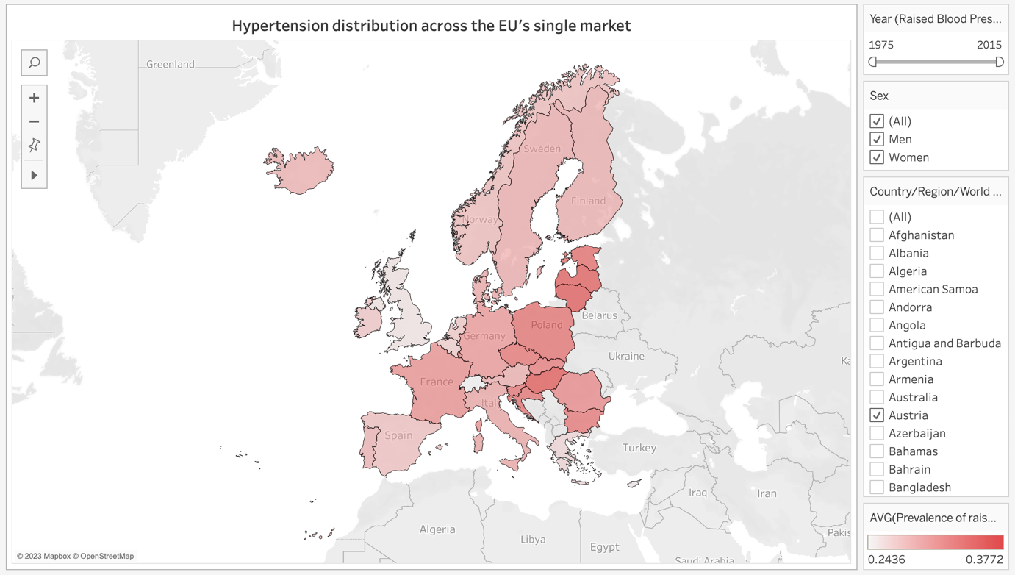

This finding is about understanding the variance of high blood pressure values in EU’s single market. The reason I chose this part in the world map because Russia was the most affected country in terms of hypertension although the overall graph from the year 1975 to 2015 has shown a decent progress in tackling with the hypertension but still it leads in the world. As some of the countries of Europe is sharing borders with Russia like Lithuania, Latvia, Estonia, Poland, Romania, etc. are affected with the hypertension but their neighboring countries are somehow handling this well and are showing quite a good progress in other parts of the EU’s single market.

What?

* The **Dataset type** used here is a **Table** where **attributes(columns) is the** **Longitude(generated)** and **items(rows) is the Latitude(generated).** The **cell containing value** will be the **value at a particular attribute and particular item**.
* The **Data Types** used here are **Items (Latitude[generated])** and **Attributes** (**Longitude[generated]**).
* The **Attribute type** used here is **Ordered** under which we are using **Quantitative** type.

Why?

* The above visualization aims to understand the differences in the high blood pressure values in the countries that comes under EU’s single market and how did they manage to cope up with the hypertension when the neighboring country (Russia) is suffering from it at greater extent.
* After **consuming** the given data and to **present** the different mean values of high blood pressure in different countries of EU’s single market, I **looked up** for the **trend** in countries (after their latitude and longitude got generated with the help of using world map view) showing different high blood pressure values and, in this case, I **browsed** for the year 1975 to 2015. I **located** the mean values of raised blood pressures in all the countries to understand the **trend** in high blood pressure values. I **compared** the high blood pressure values among male and female and then **summarized** them into one map using gender and year as filters to understand the visualization better.
* The finding above shows the **trends** of how high blood pressure or hypertension has decreased over the years in both the genders (Men and Women). There is **correlation** of different high blood pressure valuesin different subsequent year ranges.

How?

* The mark used in above graph is a **two-dimensional (2D) mark: area**.
* The **channel** used here is **Colour**. The **categorical attribute (Colour hue)** **maps to the mean of avg. raised blood pressure values**.
* The **year, gender and countries are used for filtering.**
* The chosen chart type is a good fit than others because our aim to analyze the difference of values of hypertension in EU’s single market. To present this, I need to focus only on the countries that shares the EU’s single market. I have used color hue for distinguishing between the neighboring countries that are either affected badly (0.3772), at moderate level and least affected (0.2436) with the hypertension.
* Presenting avg. raised blood pressure values with colour hue is a good option because it clearly distinguishes in the map view that which country is affected the most with the hypertension, which has moderate level, and which has the least. The colour hue visual channel helps me to achieve the aim of this investigation.

Dashboard

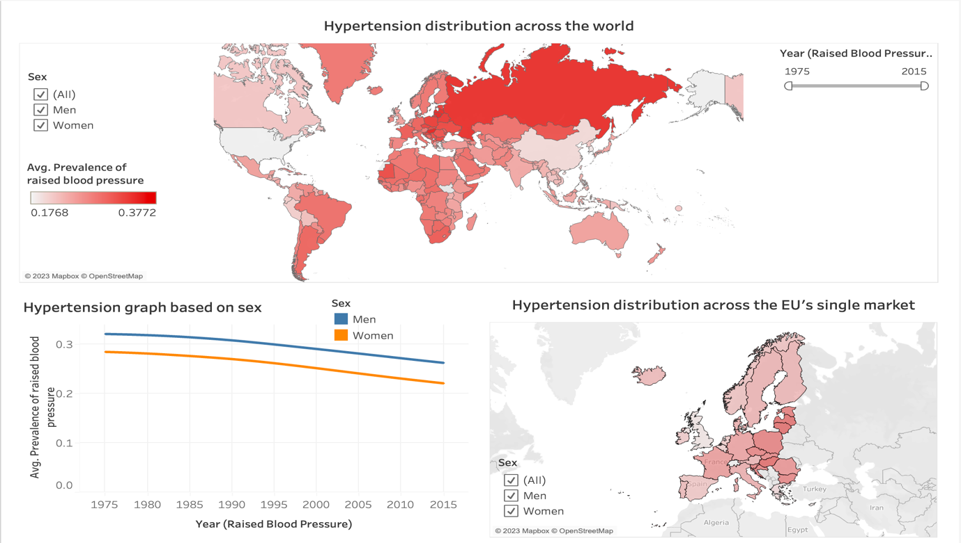

This dashboard is the summary of all the previous individual findings. The investigation started from understanding the obesity levels among both the genders (Male and Female) over the years (1975 – 2015). I deduced that both genders tend to be more obese but from the year 2006, men have shown a steep progress towards becoming more obese than women. It is because of this reason, in the diabetes graph, it was deduced that from the year 2006, men tend to be more diabetic than women. This shows the direct correlation between obesity and diabetes. Further down the investigation leads to the understanding towards high blood pressure among males and females and how it was related with the obesity. The graph (Finding 1.2) showed the gradual drop in high blood pressure among males and females over the years (1975 – 2015) and negative correlation with the obesity. These insights are coming purely on the data given and somehow, falsifying the belief in common people that obesity tends to hypertension and further effects of hypertension.

After understanding all the correlations, the idea was to understand which country is managing the hypertension well when the situations in the neighboring countries are opposite. Hypertension has become very common in the recent past years as well and that too among the youth. Therefore, I decided to gain some insights here from the given data. What I saw from Finding 2 was that Russia is the only country that has been suffering from hypertension since long although they have shown a progress in tackling the hypertension levels among men and women from 1975 – 2015. The similar impact of hypertension has also been observed in the neighboring countries of Russia like Lithuania, Latvia, Estonia, Poland, Romania, etc... Lithuania has shown the highest mean value of raised blood pressure (0.3752) and Latvia is somewhere near to it (0.3702). Going in the west towards Poland, Germany, Belgium, Netherlands, etc. we observe that the mean value of high blood pressure has decreased to a greater extent. France again showing a bit spike although being in the west of Germany and is the only exception. Other than that, all other countries are showing better performance in handling hypertension at their level.

The Finding 2 has been used as a global filter in the dashboard to visualize the different patterns and relations among males and females having high blood pressure over the years (1975 – 2015). If we want to see the overall picture of a particular EU’s single market’s country, we can simply click on that country in the world map view (Finding 2) and corresponding results will be displayed in the line chart and EU’s single market’s map view chart.